**Project Title: Touch Screen Musical App**

**This project was made in collaboration with my senior and later I used the same LCD and concept to design a joystick controller for my Hexapod robot**

**Introduction:**

Getting familiar with a technology is easier and faster than acquiring a skill. The advances in musical applications have been beneficial for unconventional musicians. Touch screen music creation applications provide accessible tools and a platform for these musicians to practice their trade.

We have succeeded in making a musical application which uses a LCD Touch Screen as the user interface. Our project provides the options of play, record and replay. The user has the options for the instruments: piano and xylophone.

**Main Modules:**

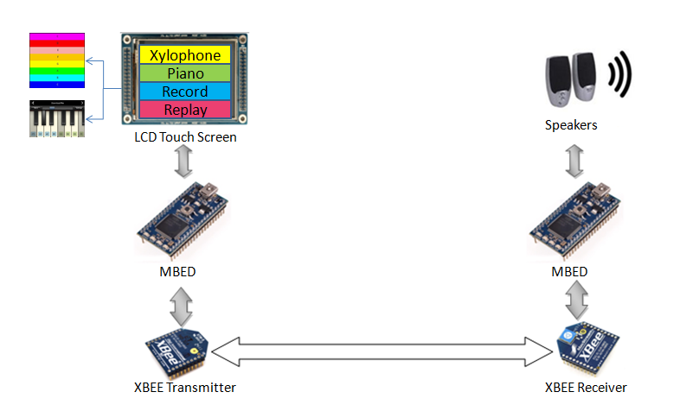

Figure 1

Our main modules consist of LCD Touch Screen, MBED LPC1768 controllers, XBEE Transmitter and Receiver, and speakers.

**Hardware Design and Implementation:**

**LCD Touch Screen:**

The LCD touch screen used consists of 2 parts: a 3.2 " TFT LCD screen and the touch panel. The TFT LCD use the control chip, HX8346 and the touch panel uses the Analog Device XPT2046 touch screen controller.

**MBED Microcontrollers:**

We have used two MBED Microcontrollers.

MBED 1:

1. It is connected to the LCD Touch Screen. The first microcontroller communicates with the LCD Touch Screen through pins p5, p9, p10, p11, p12. Pin p5 is being used as an external interrupt whenever the screen is pressed, while p9 – p12 as data pins.
2. It also controls the XBEE transmitter through pins p8, p13 and p14. Pin p8 is connected to reset of the XBEE transmitter, while pin p13 and p14 are connected to Din and Dout of XBEE transmitter respectively.

MBED 2:

1. It controls the XBEE through pins p9, p10 and p11. Pin p11 is connected to reset of the XBEE transmitter, while pin p9 and p10 are connected to Din and Dout of XBEE transmitter respectively.
2. It also controls the speaker through PWM output pin p21.

**XBEE Transmitter and Receiver:**

XBEE transmitter and receiver are used to communicate between MBED 1 and MBED 2. MBED 1 sends the note to be played by MBED 2 through transmitter and receiver.

**Software Design and Implementation:**

The user is able to play two kinds of instruments on it – xylophone and piano. Both instrumentshave a different interface. The piano part has a record and replay function.The LCD touch screen will display these instruments.The menu and keys are displayed on the LCD using (x, y) coordinates. User presses on the keyboard to play the note.The touch screen controller will signal the microcontroller through an interrupt when the screen will be pressed.

**LCD drawing**

The LCD that we used is a 3.2" TFT screen with a resolution of 320 × 240, as the following figure shows. There are 240 pixels each row and 320 pixels each column when used in portrait orientation. We have used (x, y) coordinate to represent each pixel on screen.

(0, 0) (0,239)

3.2“ TFT

(0,319) (239,319)

Figure:

**Main Menu:**

Main menu will display four options:

1. Piano

2. Xylophone

3. Record

4. Replay

**Mode 1, Piano:**

Eight keys of a piano will be displayed on the LCD once the user selects Piano. By using the (x,y) coordinates value we can determine which key is being pressed. There will be a total 3 black key and 5 white keys on the screen. That is to say, 8 notes can be generated.

**Mode 2, Xylophone:**

Six bars (rectangles) with different colors are displayed.By using the (x ,y) coordinates value we can determine which key is being pressed. 6 notes can be generated.

**Mode 3, Record:**

8 keys of piano will be displayed using which the users will play a tune to be recorded. The tune will be recorded using counters.

**Mode 4, Replay:**

The last recorded tune will be played.

**Wireless Transmission**

The two MBED microcontrollers will communicate wirelessly using XBEE module i.e. transmitter and receiver. The microcontroller connected to the LCD will send a signal to the microcontroller connected to the speakers to play a note corresponding to the key pressed.

**Note Generation**

For every key of piano and xylophone a different tune is played. There are a total of 15 different frequencies played by MBED2.TF

|  |  |
| --- | --- |
| Data lines ( D3 D2 D1 D0 ) | Frequency / Hz |
| 0001 | 277.0 |
| 0010 | 740.0 |
| 0011 | 1864.7 |
| 0100 | 246.9 |
| 0101 | 440.0 |
| 0110 | 1174.7 |
| 0111 | 2349.0 |
| 1000 | 4186.0 |
| 1001 | 2500.0 |
| 1010 | 1800.0 |
| 1011 | 1100.0 |
| 1100 | 800.0 |
| 1101 | 586.0 |
| 1110 | 493.0 |
| 1111 | 349.0 |

**Flow Chart of Main Process:**

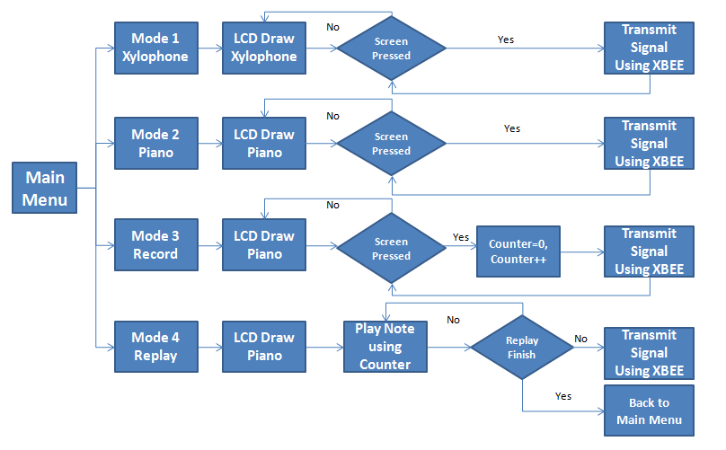

**Mode 1 Piano**

**Mode 2 Xylophone**

Figure : MBED 1

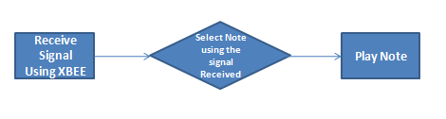

Figure : MBED 2

**List of Parts:**

|  |  |
| --- | --- |
| Speakers | 1 |
| STM32F103V​CT6 Board With 3.2" TFT LCD Module | 1 |
| MBED LPC1768 | 2 |
| XBEE Transmitter Receiver | 1 |
| Power Supply | 1 |

**Connections/Interfaces:**

1. LCD Touch Screen is connected to MBED 1 through pin p5 (InterruptIn) and p9, p10, p11, p12 (data pins).
2. XBEETransmitter is connected to serial COMM interface (p13, p14) of MBED 1 and reset pin of transmitter is connected to p8 of MBED.
3. XBEE Receiver is connected to serial COMM interface (p9, p10) of MBED 2.
4. Speaker is connected to PWM output pin p21 of MBED 2.